**Practical-1**

**Aim : Installation of Android in Windows with Simulator and Introduction to Android Life Cycle & Introduction to UI/XI.**

**STEP 1:** **DOWNLOAD AND INSTALL THE JAVA RUNTIME ENVIRONMENT (JRE)**

You can find the download file here:

[http://www.oracle.com/technetwork/java/javase/downloads/jre-6u25-download-346243.html.](http://www.oracle.com/technetwork/java/javase/downloads/jre-6u25-download-346243.html)

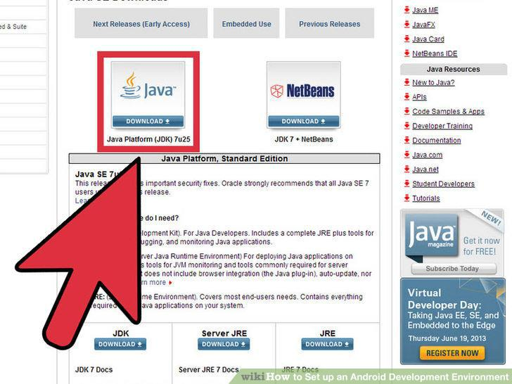

**STEP 2: DOWNLOAD AND INSTALL THE JAVA DEVELOPMENT KIT.**

On some Windows systems, the launcher script does not find where the JDK is installed. If you encounter this problem, you need to set an environment variable indicating the correct location.

Select Start menu > Computer > System Properties > Advanced System Properties. Then open Advanced tab > Environment Variables and add a new system variable JAVA_HOME that points to your JDK folder, for example C:\Program Files\Java\jdk1.7.0_21.

**STEP 3: DOWNLOAD ANDROID STUDIO**

The Android Software Development Kit (referred to in this License Agreement as the "SDK" and specifically including the Android system files, packaged APIs, and Google APIs add-ons) is licensed to you subject to the terms of this License Agreement. This License Agreement forms a legally binding contract between you and Google in relation to your use of the SDK.

**You can install android studio by following link:**

* <http://developer.android.com/sdk/index.html#top>

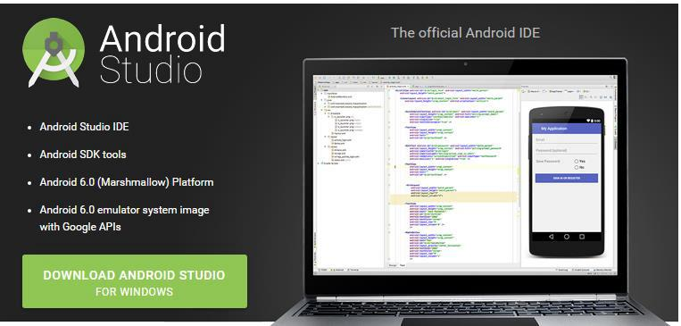

**STEP 4: ADDING SDK PACKAGES**

The Android SDK does not include everything you need to start developing. The SDK separates tools, platforms, and other components into packages you can download as needed using the [Android SDK Manager.](http://developer.android.com/tools/help/sdk-manager.html) So before you can start, there are a few packages you should add to your Android SDK.

To start adding packages, launch the Android SDK Manager in one of the following ways:

* In Android Studio, click **SDK Manager ** in the toolbar.
* If you're not using Android Studio:

1. Windows: Double-click the SDK Manager.exe file at the root of the Android SDK directory.
2. Mac/Linux: Open a terminal and navigate to the tools/ directory in the location where the Android SDK was installed, then execute android sdk.

When you open the SDK Manager for the first time, several packages are selected by default. Leave these selected, but be sure you have everything you need to get started by following these steps:

Get the latest SDK tools

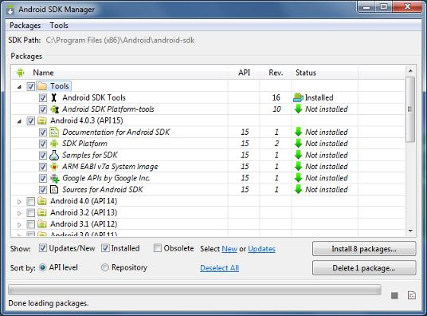

As a minimum when setting up the Android SDK, you should download the latest tools and Android platform:

1. Open the Tools directory and select:

1. **Android SDK Tools**
2. **Android SDK Platform-tools**
   1. **Android SDK Build-tools** (highest version)
3. Open the first Android X.X folder (the latest version) and select:
   1. **SDK Platform**
4. A system image for the emulator, such as

**ARM EABI v7a System Image**

Get the support library for additional APIs

The support library is required for:

* [Android Wear](http://developer.android.com/wear/index.html)
* [Android TV](http://developer.android.com/tv/index.html)
* [Google Cast](http://developer.android.com/google/play-services/cast.html)
* [Navigation drawer](http://developer.android.com/reference/android/support/v4/widget/DrawerLayout.html)
* [Swipe views](http://developer.android.com/reference/android/support/v4/view/ViewPager.html)
* [Backward-compatible action bar](http://developer.android.com/reference/android/support/v7/app/ActionBar.html)

The [Android Support Library](http://developer.android.com/tools/support-library/features.html) provides an extended set of APIs that are compatible with most versions of Android.

Open the **Extras** directory and select:

* **Android Support Repository**
* **Android Support Library**

Get Google Play services for even more APIs

The Google Play services APIs provide a variety of features and services for your Android apps, such as:

* [User authentication](http://developer.android.com/google/play-services/plus.html)
* [Google Maps](http://developer.android.com/google/play-services/maps.html)
* [Google Cast](http://developer.android.com/google/play-services/cast.html)
* [Games achievements and leaderboards](http://developer.android.com/google/play-services/games.html)
* [And much more](http://developer.android.com/google/play-services/index.html)

To develop with Google APIs, you need the Google Play services package:

Open the **Extras** directory and select:

* **Google Repository**
* **Google Play services**



**Note:** Google Play services APIs are not available on all Android-powered devices, but are available on alldevices with Google Play Store. To use these APIs in the Android emulator, you must also install the the **Google** **APIs** system image from the latest Android X.X directory in the SDK Manager.

**INSTALL THE PACKAGES**

Once you've selected all the desired packages, continue to install:

1. Click **Install X packages**.
2. In the next window, double-click each package name on the left to accept the license agreement for each.
3. Click **Install**.

The download progress is shown at the bottom of the SDK Manager window. **Do not exit the SDK Manager** or it will cancel the download.

***STEP 5: ANDROID* PROJECT VIEW**

By default, Android Studio displays your project files in the *Android* project view. This view shows a flattened version of your project's structure that provides quick access to the key source files of Android projects and helps you work with the [Gradle-based build system.](http://developer.android.com/sdk/installing/studio-build.html) The *Android* project view:

* Shows the most important source directories at the top level of the module hierarchy.
* Groups the build files for all modules in a common folder.
* Groups all the manifest files for each module in a common folder.
* Shows resource files from all Gradle source sets.
* Groups resource files for different locales, orientations, and screen types in a single group per resource type.

**Figure: Show The Android Project View.**

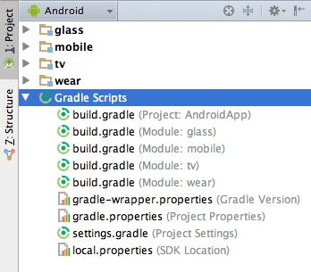

**Figure: Show Project Build Files.**

The *Android* project view shows all the build files at the top level of the project hierarchy under **Gradle Scripts**. Each project module appears as a folder at the top level of the project hierarchy and contains these four elements at the top level:

* java/ - Source files for the module.
* manifests/ - Manifest files for the module.
* res/ - Resource files for the module.
* Gradle Scripts/ - Gradle build and property files.

For example, *Android* project view groups all the instances of the ic_launcher.png resource for different screen densities under the same element.



**Note:** The project structure on disk differs from this flattened representation. To switch to back to the segregatedproject view, select **Project** from the **Project** drop-down.

Other Android Studio views

When you use the *Project* view in Android Studio, you should notice that the project structure appears different than you may be used to in Eclipse. Each instance of Android Studio contains a project with one or more application modules. Each application module folder contains the complete source sets for that module, including src/main/ andsrc/androidTest/ directories, resources, build file and the Android manifest. For the most part, you will need to modify the files under each module's src/main/ directory for source code updates, the gradle.build file for build specification and the files under src/androidTest/ directory for test case creation.

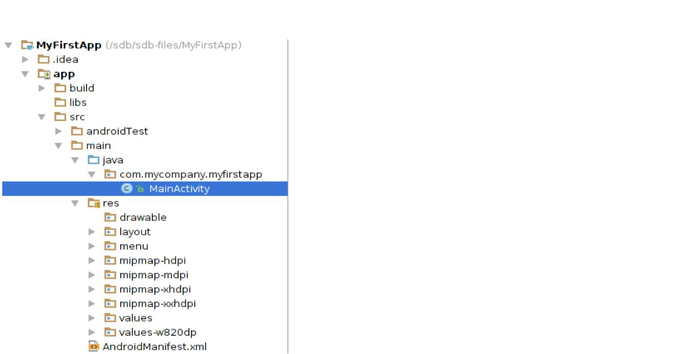

**Figure: View Android Studio *Project* structure.**

* **Android Virtual Device (AVD) Manager**

AVD Manager has updated screens with links to help you select the most popular device configurations, screen sizes and resolutions for your app previews.

Click the **Android Virtual Device Manager ** in the toolbar to open it and create new virtual devices for running your app in the emulator.

The AVD Manager comes with emulators for Nexus 6 and Nexus 9 devices and also supports creating custom Android device skins based on specific emulator properties and assigning those skins to hardware profiles. Android Studio installs the Intel® x86 Hardware Accelerated Execution Manager (HAXM) emulator accelerator and creates a default emulator for quick app prototyping.

For more information, see [Managing AVDs.](http://developer.android.com/tools/devices/managing-avds.html)

* **Android Activity Lifecycle**

Android Activity Lifecycle is controlled by 7 methods of android.app.Activity class. The android Activity is the subclass of ContextThemeWrapper class.

An activity is the single screen in android. It is like window or frame of Java.

By the help of activity, you can place all your UI components or widgets in a single screen.

The 7 lifecycle method of Activity describes how activity will behave at different states.

* **Android Activity Lifecycle methods**

|  |  |  |  |  |  |
| --- | --- | --- | --- | --- | --- |
|  | **Method** |  |  | **Description** |  |
|  |  |  |  |
|  |  |  |  |  |  |
|  |  |  |  |  |  |
|  | **onCreate** | |  | called when activity is first created. | |
|  |  | |  |  | |
|  | **onStart** | |  | called when activity is becoming visible to the user. | |
|  |  | |  |  | |
|  |  |  |  |  |  |
|  | **onResume** | |  | called when activity will start interacting with the user. | |
|  |  |  |  |  |  |

Let's see the 7 lifecycle methods of android activity.

|  |  |  |  |  |  |
| --- | --- | --- | --- | --- | --- |
|  | **onPause** |  |  | called when activity is not visible to the user. |  |
|  |  |  |  |
|  |  |  |  |
|  |  |  |  |  |  |
|  |  |  |  |  |  |
|  | **onStop** | |  | called when activity is no longer visible to the user. | |
|  |  | |  |  | |
|  | **onRestart** |  |  | called after your activity is stopped, prior to start. |  |
|  |  |  |  |  |  |
|  |  |  |  |  |  |
|  | **onDestroy** | |  | called before the activity is destroyed. | |
|  |  |  |  |  |  |

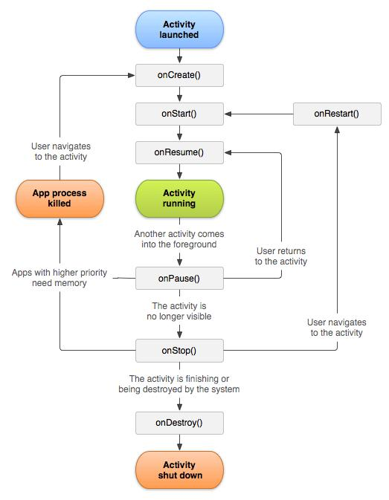

**Practical-2**

**Aim : I. Create “Hello World” application. That will display “Hello World” in the middle of the screen in the red color with white background. II.To understand Activity, Intent Create sample application with login module.(Check username and password) On successful login, go to next screen. And on failing login, alert user using Toast. Also pass username to next screen.**

* **Create “Hello World” application. That will display “Hello World” in the middle of the screen in the red color with white background**

**I)Hello World**

**Activity_main.xml**

*<?***xml version="1.0" encoding="utf-8"***?>*<**android.support.constraint.ConstraintLayout xmlns:android="http://schemas.android.com/apk/res/android"  
 xmlns:app="http://schemas.android.com/apk/res-auto"  
 xmlns:tools="http://schemas.android.com/tools"  
 android:layout_width="match_parent"  
 android:layout_height="match_parent"  
 tools:context=".MainActivity"**>  
  
 <**TextView  
 android:layout_width="wrap_content"  
 android:layout_height="69dp"  
 android:text="Hello World!"  
 android:textColor="@android:color/holo_red_dark"  
 android:textSize="36sp"  
 app:layout_constraintBottom_toBottomOf="parent"  
 app:layout_constraintLeft_toLeftOf="parent"  
 app:layout_constraintRight_toRightOf="parent"  
 app:layout_constraintTop_toTopOf="parent"** />  
</**android.support.constraint.ConstraintLayout**>

**MainActivity.java**

**package** com.example.jainilpatel.hello;  
**import** android.support.v7.app.AppCompatActivity;  
**import** android.os.Bundle;  
**public class** MainActivity **extends** AppCompatActivity {  
 @Override  
 **protected void** onCreate(Bundle savedInstanceState) {  
 **super**.onCreate(savedInstanceState);  
 setContentView(R.layout.***activity_main***); }}

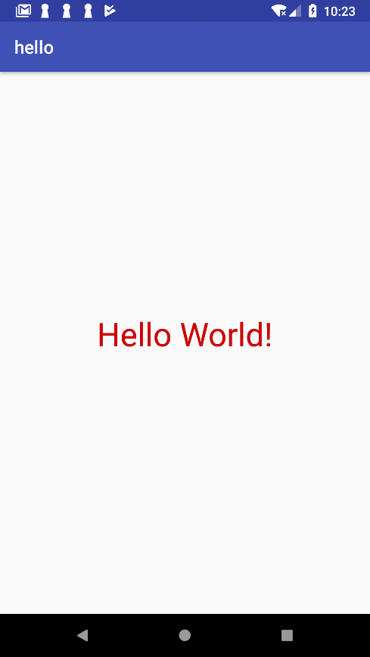

**2)Login**

**MainActivity.java**

**package** com.example.jainilpatel.practical2;  
  
**import** android.support.v7.app.AppCompatActivity;  
**import** android.os.Bundle;  
  
  
**import** android.net.Uri;  
**import** android.support.v7.app.AppCompatActivity;  
**import** android.os.Bundle;  
**import** android.content.Intent;  
**import** android.support.v7.app.AppCompatActivity;  
**import** android.os.Bundle;  
**import** android.view.View;  
**import** android.widget.Button;  
**import** android.widget.EditText;  
**import** android.widget.Toast;  
  
**import** java.lang.String;  
  
**public class** MainActivity **extends** AppCompatActivity {  
  
 Button **b1**;  
 EditText **t1**;  
 EditText **t2**;  
 EditText **t3**;  
 EditText **t4**;  
 EditText **t5**;  
  
 @Override  
 **protected void** onCreate(Bundle savedInstanceState) {  
 **super**.onCreate(savedInstanceState);  
 setContentView(R.layout.***activity_main***);  
 **t1**=(EditText)findViewById(R.id.***editText5***);  
 **t2**=(EditText)findViewById(R.id.***editText6***);  
 **t3**=(EditText)findViewById(R.id.***editText8***);  
 **t4**=(EditText)findViewById(R.id.***editText10***);  
 }  
  
  
 **public void** signup(View v)  
 {  
 String s1=**t1**.getText().toString();  
 String s2=**t2**.getText().toString();  
 String s3=**t3**.getText().toString();  
 String s4=**t4**.getText().toString();  
  
 **if**(s2.endsWith(**"@charusat.edu.in"**)&&s4.equals(**"12345"**))  
 {  
 Intent i=**new** Intent(**this**,Main2Activity.**class**);  
 i.putExtra(**"parcel_data"**, s1);  
 startActivity(i);  
 }  
 **else** {  
 Toast.*makeText*(MainActivity.**this**, **"LOGIN UNSUCCESSFUL"** , Toast.***LENGTH_SHORT***).show();  
  
 }  
 }  
}

**Main2Activity.java**

**package** com.example.jainilpatel.practical2;  
  
**import** android.content.Intent;  
**import** android.support.v7.app.AppCompatActivity;  
**import** android.os.Bundle;  
**import** android.widget.TextView;  
  
**public class** Main2Activity **extends** AppCompatActivity {  
TextView **t1**;  
 @Override  
 **protected void** onCreate(Bundle savedInstanceState) {  
 **super**.onCreate(savedInstanceState);  
 setContentView(R.layout.***activity_main2***);  
 **t1**=(TextView)findViewById(R.id.***textView***);  
 Intent i=getIntent();  
 String s=**"WELCOME "**+i.getStringExtra(**"parcel_data"**);  
 **t1**.setText(s);  
 }  
}

**activity_main.xml**

*<?***xml version="1.0" encoding="utf-8"***?>*<**RelativeLayout  
 xmlns:android="http://schemas.android.com/apk/res/android"  
 xmlns:tools="http://schemas.android.com/tools"  
 xmlns:app="http://schemas.android.com/apk/res-auto"  
 android:layout_width="match_parent"  
 android:layout_height="match_parent"  
 tools:context=".MainActivity"**>  
  
 <**EditText  
 android:layout_width="wrap_content"  
 android:layout_height="wrap_content"  
 android:inputType="textPersonName"  
 android:ems="10"  
 android:layout_alignParentTop="true"  
 android:layout_alignParentEnd="true"  
 android:layout_marginEnd="35dp"  
 android:layout_marginTop="22dp"  
 android:id="@+id/editText5"  
 android:background="@android:color/holo_blue_bright"** />  
  
 <**TextView  
 android:text="name"  
 android:layout_width="wrap_content"  
 android:layout_height="wrap_content"  
 android:layout_above="@+id/editText6"  
 android:layout_alignParentStart="true"  
 android:layout_marginStart="17dp"  
 android:id="@+id/textView7"** />  
  
 <**TextView  
 android:id="@+id/textView8"  
 android:layout_width="wrap_content"  
 android:layout_height="wrap_content"  
 android:layout_alignStart="@+id/textView7"  
 android:layout_alignTop="@+id/editText6"  
 android:text="email"** />  
  
 <**TextView  
 android:id="@+id/textView3"  
 android:layout_width="wrap_content"  
 android:layout_height="wrap_content"  
 android:layout_alignBottom="@+id/editText8"  
 android:layout_alignStart="@+id/textView7"  
 android:text="Confirm Password"** />  
  
 <**TextView  
 android:id="@+id/textView10"  
 android:layout_width="wrap_content"  
 android:layout_height="wrap_content"  
 android:layout_alignStart="@+id/textView7"  
 android:layout_alignTop="@+id/editText10"  
 android:text="password"** />  
  
 <**EditText  
 android:id="@+id/editText8"  
 android:layout_width="wrap_content"  
 android:layout_height="wrap_content"  
 android:layout_alignParentTop="true"  
 android:layout_alignStart="@+id/editText5"  
 android:layout_marginTop="131dp"  
 android:background="@android:color/holo_blue_bright"  
 android:ems="10"  
 android:inputType="textPersonName"** />  
  
 <**EditText  
 android:id="@+id/editText10"  
 android:layout_width="wrap_content"  
 android:layout_height="wrap_content"  
 android:layout_alignParentTop="true"  
 android:layout_alignStart="@+id/editText5"  
 android:layout_marginTop="96dp"  
 android:background="@android:color/holo_blue_bright"  
 android:ems="10"  
 android:inputType="textPersonName"** />  
  
 <**EditText  
 android:layout_width="wrap_content"  
 android:layout_height="wrap_content"  
 android:inputType="textPersonName"  
 android:ems="10"  
 android:layout_marginTop="13dp"  
 android:id="@+id/editText6"  
 android:background="@android:color/holo_blue_bright"  
 android:layout_below="@+id/editText5"  
 android:layout_alignStart="@+id/editText5"** />  
  
 <**Button  
 android:id="@+id/button2"  
 android:layout_width="wrap_content"  
 android:layout_height="wrap_content"  
 android:layout_alignParentTop="true"  
 android:layout_centerHorizontal="true"  
 android:layout_marginTop="188dp"  
 android:onClick="signup"  
 android:text="Sign In"** />  
  
 <**TextView  
 android:id="@+id/textView2"  
 android:layout_width="wrap_content"  
 android:layout_height="wrap_content"  
 android:layout_alignParentBottom="true"  
 android:layout_centerHorizontal="true"  
 android:layout_marginBottom="45dp"  
 android:text="DEVELOPED BY 16CE068"** />  
  
</**RelativeLayout**>

**activity_main2.xml**

*<?***xml version="1.0" encoding="utf-8"***?>*<**android.support.constraint.ConstraintLayout xmlns:android="http://schemas.android.com/apk/res/android"  
 xmlns:app="http://schemas.android.com/apk/res-auto"  
 xmlns:tools="http://schemas.android.com/tools"  
 android:layout_width="match_parent"  
 android:layout_height="match_parent"  
 tools:context=".Main2Activity"**>  
  
 <**TextView  
 android:id="@+id/textView"  
 android:layout_width="wrap_content"  
 android:layout_height="wrap_content"  
 android:text="TextView"  
 app:layout_constraintBottom_toBottomOf="parent"  
 app:layout_constraintEnd_toEndOf="parent"  
 app:layout_constraintStart_toStartOf="parent"  
 app:layout_constraintTop_toTopOf="parent"** />  
</**android.support.constraint.ConstraintLayout**>

**Output:**

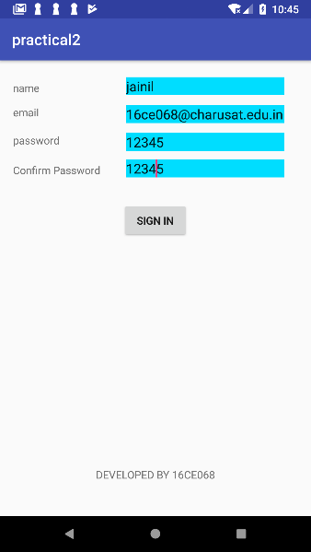 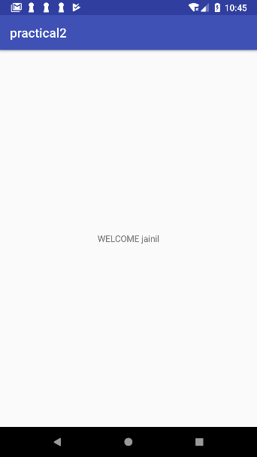

**Practical-3**

**Aim : Create login application where you will have to validate EmailID (UserName). Till the username and password is not validated , login button should remain disabled. Create and Login application as above . On successful login , open browser with any URL.**

**Code:**

**Activitymain.java**

**package** com.example.jainilpatel.practical3;  
  
**import** android.support.v7.app.AppCompatActivity;  
**import** android.os.Bundle;  
**import** android.net.Uri;  
**import** android.content.Intent;  
**import** android.view.View;  
**import** android.widget.Button;  
**import** android.widget.EditText;  
**import** android.widget.Toast;  
  
**import** java.lang.String;  
  
**public class** MainActivity **extends** AppCompatActivity {  
  
 Button **b1**;  
 EditText **t1**;  
 EditText **t2**;  
 EditText **t3**;  
 EditText **t4**;  
 EditText **t5**;  
  
 @Override  
 **protected void** onCreate(Bundle savedInstanceState) {  
 **super**.onCreate(savedInstanceState);  
 setContentView(R.layout.***activity_main***);  
 **b1**=(Button)findViewById(R.id.***button***);  
 **t1**=(EditText)findViewById(R.id.***editText5***);  
 **t2**=(EditText)findViewById(R.id.***editText6***);  
 **t3**=(EditText)findViewById(R.id.***editText8***);  
 **t4**=(EditText)findViewById(R.id.***editText10***);  
 **t4**.setOnFocusChangeListener(**new** View.OnFocusChangeListener() {  
  
 @Override  
 **public void** onFocusChange(View v, **boolean** hasFocus) {  
  
 {  
 xyz();  
  
 }  
 }  
 }  
 );  
  
  
 }  
  
 **public void** xyz()  
 {  
  
 String s1=**t1**.getText().toString();  
 String s2=**t2**.getText().toString();  
 String s3=**t3**.getText().toString();  
 String s4=**t4**.getText().toString();  
  
 **if**(s2.endsWith(**"@charusat.edu.in"**)&&s4.equals(**"12345"**))  
 {  
 **b1**.setEnabled(**true**);  
  
 }  
  
 }  
  
  
  
 **public void** btnclick(View v)  
 {  
  
 String s1=**t1**.getText().toString();  
 String s2=**t2**.getText().toString();  
 String s3=**t3**.getText().toString();  
 String s4=**t4**.getText().toString();  
  
 **if**(s2.endsWith(**"@charusat.edu.in"**)&&s4.equals(**"12345"**))  
 {  
 Toast.*makeText*(MainActivity.**this**, **"LOGIN SUCCESSFUL"** , Toast.***LENGTH_SHORT***).show();  
 Intent j=**new** Intent(Intent.***ACTION_VIEW***, Uri.*parse*(**"http://google.com"**));  
 startActivity(j);  
  
 }  
 **else** {  
 Toast.*makeText*(MainActivity.**this**, **"LOGIN UNSUCCESSFUL"** , Toast.***LENGTH_SHORT***).show();  
  
 }  
  
 }  
}

**Activity_main.xml**

*<?***xml version="1.0" encoding="utf-8"***?>*<**RelativeLayout  
 xmlns:android="http://schemas.android.com/apk/res/android"  
 xmlns:tools="http://schemas.android.com/tools"  
 xmlns:app="http://schemas.android.com/apk/res-auto"  
 android:layout_width="match_parent"  
 android:layout_height="match_parent"  
 tools:context=".MainActivity"**>  
  
 <**EditText  
 android:layout_width="wrap_content"  
 android:layout_height="wrap_content"  
 android:inputType="textPersonName"  
 android:ems="10"  
 android:layout_alignParentTop="true"  
 android:layout_alignParentEnd="true"  
 android:layout_marginEnd="35dp"  
 android:layout_marginTop="22dp"  
 android:id="@+id/editText5"  
 android:background="@android:color/holo_blue_bright"** />  
  
 <**TextView  
 android:text="name"  
 android:layout_width="wrap_content"  
 android:layout_height="wrap_content"  
 android:layout_above="@+id/editText6"  
 android:layout_alignParentStart="true"  
 android:layout_marginStart="17dp"  
 android:id="@+id/textView7"** />  
  
 <**TextView  
 android:id="@+id/textView8"  
 android:layout_width="wrap_content"  
 android:layout_height="wrap_content"  
 android:layout_alignStart="@+id/textView7"  
 android:layout_alignTop="@+id/editText6"  
 android:text="email"** />  
  
 <**TextView  
 android:id="@+id/textView3"  
 android:layout_width="wrap_content"  
 android:layout_height="wrap_content"  
 android:layout_alignBottom="@+id/editText8"  
 android:layout_alignStart="@+id/textView7"  
 android:text="Confirm Password"** />  
  
 <**TextView  
 android:id="@+id/textView10"  
 android:layout_width="wrap_content"  
 android:layout_height="wrap_content"  
 android:layout_alignStart="@+id/textView7"  
 android:layout_alignTop="@+id/editText10"  
 android:text="password"** />  
  
 <**EditText  
 android:id="@+id/editText8"  
 android:layout_width="wrap_content"  
 android:layout_height="wrap_content"  
 android:layout_alignParentTop="true"  
 android:layout_alignStart="@+id/editText5"  
 android:layout_marginTop="131dp"  
 android:background="@android:color/holo_blue_bright"  
 android:ems="10"  
 android:inputType="textPersonName"** />  
  
 <**EditText  
 android:id="@+id/editText10"  
 android:layout_width="wrap_content"  
 android:layout_height="wrap_content"  
 android:layout_alignParentTop="true"  
 android:layout_alignStart="@+id/editText5"  
 android:layout_marginTop="96dp"  
 android:background="@android:color/holo_blue_bright"  
 android:ems="10"  
 android:inputType="textPersonName"** />  
  
 <**Button  
 android:id="@+id/button"  
 android:layout_width="wrap_content"  
 android:layout_height="wrap_content"  
 android:layout_alignParentTop="true"  
 android:layout_centerHorizontal="true"  
 android:layout_marginTop="197dp"  
 android:enabled="false"  
 android:onClick="btnclick"  
 android:text="click"** />  
  
 <**EditText  
 android:layout_width="wrap_content"  
 android:layout_height="wrap_content"  
 android:inputType="textPersonName"  
 android:ems="10"  
 android:layout_marginTop="13dp"  
 android:id="@+id/editText6"  
 android:background="@android:color/holo_blue_bright"  
 android:layout_below="@+id/editText5"  
 android:layout_alignStart="@+id/editText5"** />  
  
</**RelativeLayout**>

**Output:**

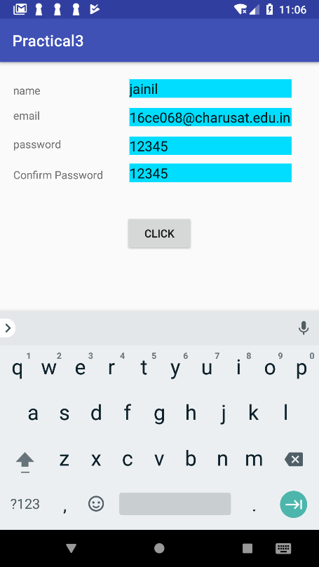 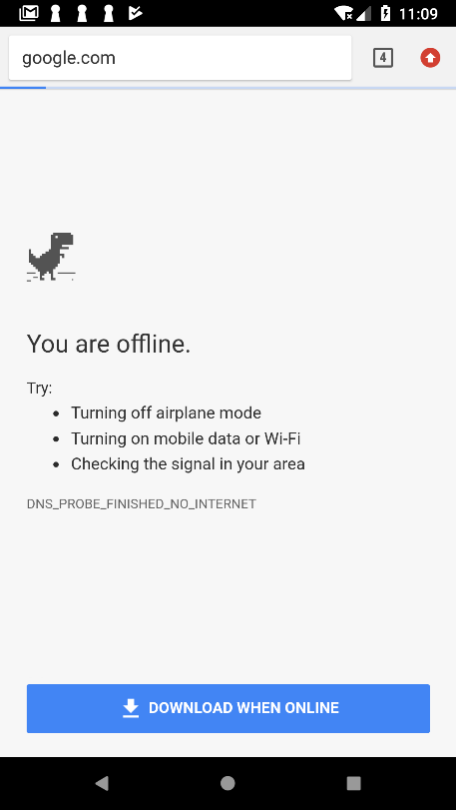

**Practical-4**

**Aim : Create an application that will pass some number to the next screen and on the next screen that number of items should be display in the list. Understand resource folders :**

**Create spinner with strings taken from resource folder(res >> value folder).**

**On changing spinner value, change image. Understand Menu option.**

**Create an application that will change color of the screen, based on selected**

**options from the menu.**

**MainActivity.java**

**package** com.example.jainilpatel.myapplication;  
  
**import** android.net.Uri;  
**import** android.support.v7.app.AppCompatActivity;  
**import** android.os.Bundle;  
**import** android.content.Intent;  
**import** android.support.v7.app.AppCompatActivity;  
**import** android.os.Bundle;  
**import** android.view.View;  
**import** android.widget.Button;  
**import** android.widget.EditText;  
**import** android.widget.Toast;  
  
**import** java.lang.String;  
  
**public class** MainActivity **extends** AppCompatActivity {  
  
 Button **b1**;  
 EditText **t1**;  
 EditText **t2**;  
 EditText **t3**;  
 EditText **t4**;  
 EditText **t5**;  
  
 @Override  
 **protected void** onCreate(Bundle savedInstanceState) {  
 **super**.onCreate(savedInstanceState);  
 setContentView(R.layout.***activity_main***);  
 **b1**=(Button)findViewById(R.id.***button***);  
 **t1**=(EditText)findViewById(R.id.***editText5***);  
 **t2**=(EditText)findViewById(R.id.***editText6***);  
 **t3**=(EditText)findViewById(R.id.***editText8***);  
 **t4**=(EditText)findViewById(R.id.***editText10***);  
 **t5**=(EditText)findViewById(R.id.***editText***);  
 **t4**.setOnFocusChangeListener(**new** View.OnFocusChangeListener() {  
  
 @Override  
 **public void** onFocusChange(View v, **boolean** hasFocus) {  
  
 {  
 xyz();  
  
 }  
 }  
 }  
 );  
  
  
 }  
  
 **public void** xyz()  
 {  
  
 String s1=**t1**.getText().toString();  
 String s2=**t2**.getText().toString();  
 String s3=**t3**.getText().toString();  
 String s4=**t4**.getText().toString();  
  
 **if**(s2.endsWith(**"@charusat.edu.in"**)&&s4.equals(**"12345"**))  
 {  
 **b1**.setEnabled(**true**);  
  
 }  
  
 }  
  
  
  
 **public void** btnclick(View v)  
 {  
  
 String s1=**t1**.getText().toString();  
 String s2=**t2**.getText().toString();  
 String s3=**t3**.getText().toString();  
 String s4=**t4**.getText().toString();  
  
 **if**(s2.endsWith(**"@charusat.edu.in"**)&&s4.equals(**"12345"**))  
 {  
 Toast.*makeText*(MainActivity.**this**, **"LOGIN SUCCESSFUL"** , Toast.***LENGTH_SHORT***).show();  
 Intent j=**new** Intent(Intent.***ACTION_VIEW***, Uri.*parse*(**"http://google.com"**));  
 startActivity(j);  
 *// Intent i=new Intent(this,Main2Activity.class);  
 //i.putExtra("parcel_data", s1);  
 // startActivity(i);* }  
 **else** {  
 Toast.*makeText*(MainActivity.**this**, **"LOGIN UNSUCCESSFUL"** , Toast.***LENGTH_SHORT***).show();  
  
 }  
 *//Toast.makeText(MainActivity.this, s1+" "+s2+ " "+ s3 +" "+s4 , Toast.LENGTH_SHORT).show();* }  
  
 **public void** signup(View v)  
 {  
 String s5=**t5**.getText().toString();  
 Intent i=**new** Intent(**this**,Main3Activity.**class**);  
 i.putExtra(**"parcel_data"**, s5);  
 startActivity(i);  
 }  
}

**Main2Activity.java**

**package** com.example.jainilpatel.myapplication;  
  
**import** android.os.Bundle;  
**import** android.support.design.widget.FloatingActionButton;  
**import** android.support.design.widget.Snackbar;  
**import** android.support.v7.app.AppCompatActivity;  
**import** android.support.v7.widget.Toolbar;  
**import** android.view.View;  
  
  
  
**import** android.support.v7.app.AppCompatActivity;  
**import** android.os.Bundle;  
**import** android.widget.TextView;  
  
  
  
**public class** Main2Activity **extends** AppCompatActivity {  
  
 @Override  
 **protected void** onCreate(Bundle savedInstanceState) {  
 **super**.onCreate(savedInstanceState);  
 setContentView(R.layout.***activity_main2***);  
 Toolbar toolbar = (Toolbar) findViewById(R.id.***toolbar***);  
 setSupportActionBar(toolbar);  
  
 FloatingActionButton fab = (FloatingActionButton) findViewById(R.id.***fab***);  
 fab.setOnClickListener(**new** View.OnClickListener() {  
 @Override  
 **public void** onClick(View view) {  
 Snackbar.*make*(view, **"Replace with your own action"**, Snackbar.***LENGTH_LONG***)  
 .setAction(**"Action"**, **null**).show();  
 }  
 });  
 }  
  
}

**Main3Activity.java**

**package** com.example.jainilpatel.myapplication;  
  
**import** android.content.Intent;  
**import** android.support.v7.app.AppCompatActivity;  
**import** android.os.Bundle;  
**import** android.view.View;  
**import** android.widget.AdapterView;  
**import** android.widget.ArrayAdapter;  
**import** android.widget.ListView;  
**import** android.widget.TextView;  
**import** android.widget.Toast;  
  
**import** java.util.ArrayList;  
  
**public class** Main3Activity **extends** AppCompatActivity {  
  
 String **s**;  
 ListView **list**;  
 ArrayList<String> **arr**;  
  
 @Override  
 **protected void** onCreate(Bundle savedInstanceState) {  
 **super**.onCreate(savedInstanceState);  
 setContentView(R.layout.***activity_main3***);  
 Intent intent=getIntent();  
 **s**=intent.getStringExtra(**"parcel_data"**);  
  
 **list**=(ListView)findViewById(R.id.***list***);  
 **arr**=**new** ArrayList<String>();  
 **for**(**int** i=1;i<=Integer.*parseInt*(**s**);i++)  
 {  
 **arr**.add(**"Person:"**+i);  
 }  
  
 **final** ArrayAdapter arrayAdapter=**new** ArrayAdapter(**this**,android.R.layout.***simple_list_item_1***,**arr**);  
  
 **list**.setAdapter(arrayAdapter);  
 **list**.setOnItemClickListener(**new** AdapterView.OnItemClickListener() {  
 @Override  
 **public void** onItemClick(AdapterView<?> parent, View view, **int** position, **long** id) {  
 String s=**"ITEM CLICKED"**+(position+1);  
 Toast.*makeText*(Main3Activity.**this**, s, Toast.***LENGTH_SHORT***).show();  
  
 Intent i=**new** Intent(Main3Activity.**this**,Main5Activity.**class**);  
 i.putExtra(**"number"**,**"963851952"**+position);  
 startActivity(i);  
 }  
 });  
 }  
 **public void** click(View v)  
 {  
 Intent i=**new** Intent(**this**,Main4Activity.**class**);  
  
 startActivity(i);  
 }  
}

**Main4Activity.java**

**package** com.example.jainilpatel.myapplication;  
  
**import** android.support.v7.app.AppCompatActivity;  
**import** android.os.Bundle;  
**import** android.view.View;  
**import** android.widget.Adapter;  
**import** android.widget.AdapterView;  
**import** android.widget.ArrayAdapter;  
**import** android.widget.ImageView;  
**import** android.widget.Spinner;  
  
**import** java.util.ArrayList;  
**import** java.util.List;  
  
**public class** Main4Activity **extends** AppCompatActivity **implements** AdapterView.OnItemSelectedListener{  
 Spinner **s**;  
 ImageView **im**;  
 @Override  
 **protected void** onCreate(Bundle savedInstanceState) {  
 **super**.onCreate(savedInstanceState);  
 setContentView(R.layout.***activity_main4***);  
 **s**=(Spinner)findViewById(R.id.***spinner***);  
 **im**=(ImageView)findViewById(R.id.***imageView***);  
 **s**.setOnItemSelectedListener(**this**);  
  
 *// Spinner Drop down elements  
  
  
 // Creating adapter for spinner* ArrayAdapter<CharSequence> dataAdapter = ArrayAdapter.*createFromResource*(**this**,R.array.***country***,R.layout.***support_simple_spinner_dropdown_item***);  
  
 *// Drop down layout style - list view with radio button* dataAdapter.setDropDownViewResource(android.R.layout.***simple_spinner_dropdown_item***);  
  
 *// attaching data adapter to spinner* **s**.setAdapter(dataAdapter);  
  
  
 }  
  
 @Override  
 **public void** onItemSelected(AdapterView<?> parent, View view, **int** position, **long** id) {  
 **switch**(position)  
 {  
 **case** 0:  
 **im**.setImageResource(R.drawable.***ic_launcher_background***);  
 **break**;  
 **case** 1:  
 **im**.setImageResource(R.drawable.***ic_launcher_foreground***);  
 **break**;  
 **case** 2:  
 **im**.setImageResource(R.drawable.***ic_launcher_background***);  
 **break**;  
 **case** 3:  
 **im**.setImageResource(R.drawable.***ic_launcher_foreground***);  
 **break**;  
 **case** 4:  
 **im**.setImageResource(R.drawable.***ic_launcher_background***);  
 **break**;  
 **case** 5:  
 **im**.setImageResource(R.drawable.***ic_launcher_foreground***);  
 **break**;  
 **case** 6:  
 **im**.setImageResource(R.drawable.***ic_launcher_background***);  
 **break**;  
 }  
 }  
  
 @Override  
 **public void** onNothingSelected(AdapterView<?> parent) {  
  
 }  
}

**Main5Activity.java**

**package** com.example.jainilpatel.myapplication;  
  
**import** android.content.Intent;  
**import** android.support.v7.app.AppCompatActivity;  
**import** android.os.Bundle;  
**import** android.widget.TextView;  
  
**public class** Main5Activity **extends** AppCompatActivity {  
TextView **t**;  
 @Override  
 **protected void** onCreate(Bundle savedInstanceState) {  
 **super**.onCreate(savedInstanceState);  
 setContentView(R.layout.***activity_main5***);  
 **t**=(TextView)findViewById(R.id.***textView2***);  
 Intent i=getIntent();  
 String s=i.getStringExtra(**"number"**);  
 **t**.setText(**"NUMBER IS "**+s);  
 }  
}

**Activity_main.xml**

*<?***xml version="1.0" encoding="utf-8"***?>*<**RelativeLayout  
 xmlns:android="http://schemas.android.com/apk/res/android"  
 xmlns:tools="http://schemas.android.com/tools"  
 xmlns:app="http://schemas.android.com/apk/res-auto"  
 android:layout_width="match_parent"  
 android:layout_height="match_parent"  
 tools:context=".MainActivity"**>  
  
 <**EditText  
 android:layout_width="wrap_content"  
 android:layout_height="wrap_content"  
 android:inputType="textPersonName"  
 android:ems="10"  
 android:layout_alignParentTop="true"  
 android:layout_alignParentEnd="true"  
 android:layout_marginEnd="35dp"  
 android:layout_marginTop="22dp"  
 android:id="@+id/editText5"  
 android:background="@android:color/holo_blue_bright"** />  
  
 <**TextView  
 android:text="name"  
 android:layout_width="wrap_content"  
 android:layout_height="wrap_content"  
 android:layout_above="@+id/editText6"  
 android:layout_alignParentStart="true"  
 android:layout_marginStart="17dp"  
 android:id="@+id/textView7"** />  
  
 <**TextView  
 android:id="@+id/textView8"  
 android:layout_width="wrap_content"  
 android:layout_height="wrap_content"  
 android:layout_alignStart="@+id/textView7"  
 android:layout_alignTop="@+id/editText6"  
 android:text="email"** />  
  
 <**TextView  
 android:id="@+id/textView9"  
 android:layout_width="wrap_content"  
 android:layout_height="wrap_content"  
 android:layout_alignParentTop="true"  
 android:layout_alignStart="@+id/textView7"  
 android:layout_marginTop="170dp"  
 android:text="NUMBER"** />  
  
 <**TextView  
 android:id="@+id/textView3"  
 android:layout_width="wrap_content"  
 android:layout_height="wrap_content"  
 android:layout_alignBottom="@+id/editText8"  
 android:layout_alignStart="@+id/textView7"  
 android:text="Confirm Password"** />  
  
 <**TextView  
 android:id="@+id/textView10"  
 android:layout_width="wrap_content"  
 android:layout_height="wrap_content"  
 android:layout_alignStart="@+id/textView7"  
 android:layout_alignTop="@+id/editText10"  
 android:text="password"** />  
  
 <**EditText  
 android:id="@+id/editText8"  
 android:layout_width="wrap_content"  
 android:layout_height="wrap_content"  
 android:layout_alignParentTop="true"  
 android:layout_alignStart="@+id/editText5"  
 android:layout_marginTop="131dp"  
 android:background="@android:color/holo_blue_bright"  
 android:ems="10"  
 android:inputType="textPersonName"** />  
  
 <**EditText  
 android:id="@+id/editText"  
 android:layout_width="wrap_content"  
 android:layout_height="wrap_content"  
 android:layout_alignStart="@+id/editText5"  
 android:layout_alignTop="@+id/textView9"  
 android:background="@android:color/holo_blue_bright"  
 android:ems="10"  
 android:inputType="textPersonName"** />  
  
 <**EditText  
 android:id="@+id/editText10"  
 android:layout_width="wrap_content"  
 android:layout_height="wrap_content"  
 android:layout_alignParentTop="true"  
 android:layout_alignStart="@+id/editText5"  
 android:layout_marginTop="96dp"  
 android:background="@android:color/holo_blue_bright"  
 android:ems="10"  
 android:inputType="textPersonName"** />  
  
 <**Button  
 android:id="@+id/button"  
 android:layout_width="wrap_content"  
 android:layout_height="wrap_content"  
 android:layout_alignParentTop="true"  
 android:layout_centerHorizontal="true"  
 android:layout_marginTop="197dp"  
 android:enabled="false"  
 android:onClick="btnclick"  
 android:text="click"** />  
  
 <**EditText  
 android:layout_width="wrap_content"  
 android:layout_height="wrap_content"  
 android:inputType="textPersonName"  
 android:ems="10"  
 android:layout_marginTop="13dp"  
 android:id="@+id/editText6"  
 android:background="@android:color/holo_blue_bright"  
 android:layout_below="@+id/editText5"  
 android:layout_alignStart="@+id/editText5"** />  
  
 <**Button  
 android:id="@+id/button2"  
 android:layout_width="wrap_content"  
 android:layout_height="wrap_content"  
 android:layout_alignParentBottom="true"  
 android:layout_centerHorizontal="true"  
 android:layout_marginBottom="196dp"  
 android:onClick="signup"  
 android:text="Sign Up"** />  
  
</**RelativeLayout**>

**Activity_main2.xml**

*<?***xml version="1.0" encoding="utf-8"***?>*<**android.support.design.widget.CoordinatorLayout xmlns:android="http://schemas.android.com/apk/res/android"  
 xmlns:app="http://schemas.android.com/apk/res-auto"  
 xmlns:tools="http://schemas.android.com/tools"  
 android:layout_width="match_parent"  
 android:layout_height="match_parent"  
 tools:context=".Main2Activity"**>  
  
 <**android.support.design.widget.AppBarLayout  
 android:layout_width="match_parent"  
 android:layout_height="wrap_content"  
 android:theme="@style/AppTheme.AppBarOverlay"**>  
  
 <**android.support.v7.widget.Toolbar  
 android:id="@+id/toolbar"  
 android:layout_width="match_parent"  
 android:layout_height="?attr/actionBarSize"  
 android:background="?attr/colorPrimary"  
 app:popupTheme="@style/AppTheme.PopupOverlay"** />  
  
 </**android.support.design.widget.AppBarLayout**>  
  
 <**include layout="@layout/content_main2"** />  
  
 <**android.support.design.widget.FloatingActionButton  
 android:id="@+id/fab"  
 android:layout_width="wrap_content"  
 android:layout_height="wrap_content"  
 android:layout_gravity="bottom|end"  
 android:layout_margin="@dimen/fab_margin"  
 app:srcCompat="@android:drawable/ic_dialog_email"** />  
  
</**android.support.design.widget.CoordinatorLayout**>

**Context_main2.xml**

*<?***xml version="1.0" encoding="utf-8"***?>*<**android.support.constraint.ConstraintLayout xmlns:android="http://schemas.android.com/apk/res/android"  
 xmlns:app="http://schemas.android.com/apk/res-auto"  
 xmlns:tools="http://schemas.android.com/tools"  
 android:layout_width="match_parent"  
 android:layout_height="match_parent"  
 app:layout_behavior="@string/appbar_scrolling_view_behavior"  
 tools:context=".Main2Activity"  
 tools:showIn="@layout/activity_main2"**>  
  
 <**TextView  
 android:id="@+id/textView"  
 android:layout_width="wrap_content"  
 android:layout_height="wrap_content"  
 android:text="Welcome To Charusat"  
 android:textColor="@android:color/holo_red_dark"  
 app:layout_constraintBottom_toBottomOf="parent"  
 app:layout_constraintEnd_toEndOf="parent"  
 app:layout_constraintStart_toStartOf="parent"  
 app:layout_constraintTop_toTopOf="parent"** />  
</**android.support.constraint.ConstraintLayout**>

**Activity_main3.xml**

*<?***xml version="1.0" encoding="utf-8"***?>*<**android.support.constraint.ConstraintLayout xmlns:android="http://schemas.android.com/apk/res/android"  
 xmlns:app="http://schemas.android.com/apk/res-auto"  
 xmlns:tools="http://schemas.android.com/tools"  
 android:layout_width="match_parent"  
 android:layout_height="match_parent"  
 tools:context=".Main3Activity"**>  
  
 <**Button  
 android:id="@+id/button3"  
 android:layout_width="wrap_content"  
 android:layout_height="wrap_content"  
 android:layout_marginBottom="8dp"  
 android:layout_marginTop="8dp"  
 android:onClick="click"  
 android:text="Button"  
 app:layout_constraintBottom_toBottomOf="parent"  
 app:layout_constraintEnd_toEndOf="parent"  
 app:layout_constraintStart_toStartOf="parent"  
 app:layout_constraintTop_toTopOf="parent"  
 app:layout_constraintVertical_bias="0.711"** />  
  
 <**ListView  
 android:id="@+id/list"  
 android:layout_width="344dp"  
 android:layout_height="305dp"  
 android:layout_marginBottom="8dp"  
 android:layout_marginTop="8dp"  
 app:layout_constraintBottom_toBottomOf="parent"  
 app:layout_constraintEnd_toEndOf="parent"  
 app:layout_constraintStart_toStartOf="parent"  
 app:layout_constraintTop_toTopOf="parent"  
 app:layout_constraintVertical_bias="0.0"** />  
</**android.support.constraint.ConstraintLayout**>

**Activity_main4.xml**

*<?***xml version="1.0" encoding="utf-8"***?>*<**android.support.constraint.ConstraintLayout xmlns:android="http://schemas.android.com/apk/res/android"  
 xmlns:app="http://schemas.android.com/apk/res-auto"  
 xmlns:tools="http://schemas.android.com/tools"  
 android:layout_width="match_parent"  
 android:layout_height="match_parent"  
 tools:context=".Main4Activity"**>  
 <**ImageView  
 android:id="@+id/imageView"  
 android:layout_width="229dp"  
 android:layout_height="311dp"  
 android:layout_marginTop="184dp"  
 app:layout_constraintEnd_toEndOf="parent"  
 app:layout_constraintHorizontal_bias="0.503"  
 app:layout_constraintStart_toStartOf="parent"  
 app:layout_constraintTop_toTopOf="parent"  
 app:srcCompat="@android:drawable/presence_audio_online"** />  
 <**Spinner  
 android:id="@+id/spinner"  
 android:layout_width="368dp"  
 android:layout_height="wrap_content"  
 android:layout_marginTop="16dp"  
 app:layout_constraintEnd_toEndOf="parent"  
 app:layout_constraintStart_toStartOf="parent"  
 app:layout_constraintTop_toTopOf="parent"** />  
</**android.support.constraint.ConstraintLayout**>

**Activity_main5.xml**

*<?***xml version="1.0" encoding="utf-8"***?>*<**android.support.constraint.ConstraintLayout xmlns:android="http://schemas.android.com/apk/res/android"  
 xmlns:app="http://schemas.android.com/apk/res-auto"  
 xmlns:tools="http://schemas.android.com/tools"  
 android:layout_width="match_parent"  
 android:layout_height="match_parent"  
 tools:context=".Main5Activity"**>  
  
 <**TextView  
 android:id="@+id/textView2"  
 android:layout_width="wrap_content"  
 android:layout_height="wrap_content"  
 android:layout_marginEnd="8dp"  
 android:layout_marginTop="8dp"  
 android:text="TextView"  
 app:layout_constraintBottom_toBottomOf="parent"  
 app:layout_constraintEnd_toEndOf="parent"  
 app:layout_constraintStart_toStartOf="parent"  
 app:layout_constraintTop_toTopOf="parent"** />  
</**android.support.constraint.ConstraintLayout**>

**Output:**

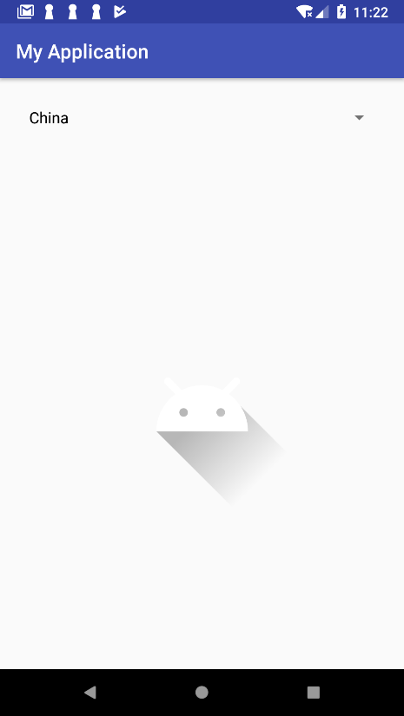 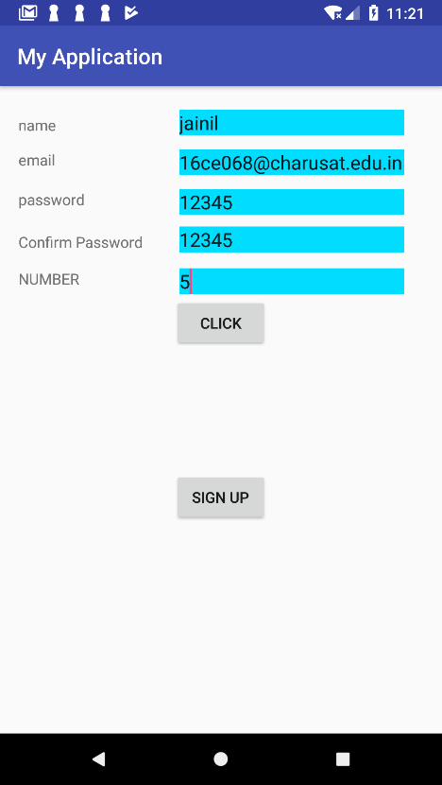

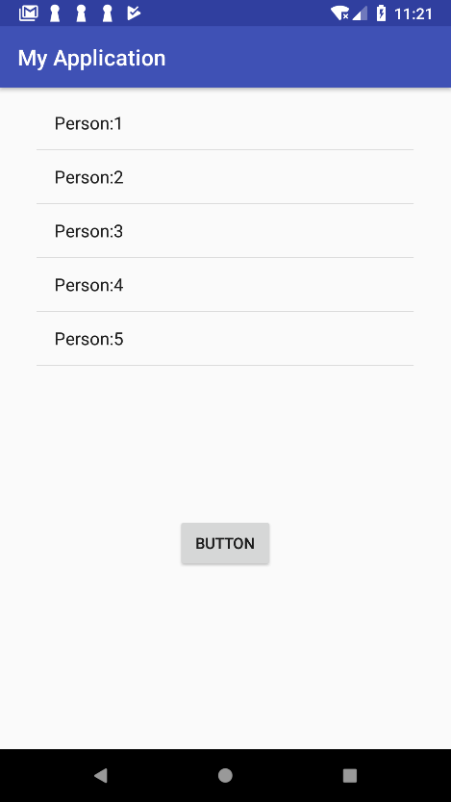 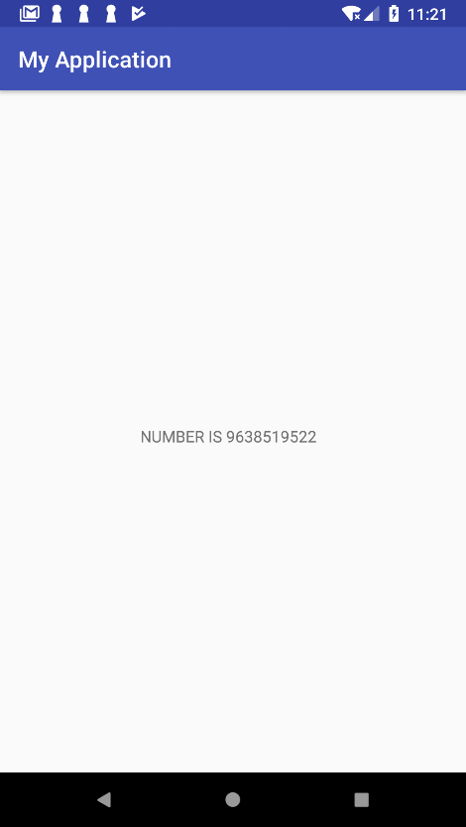

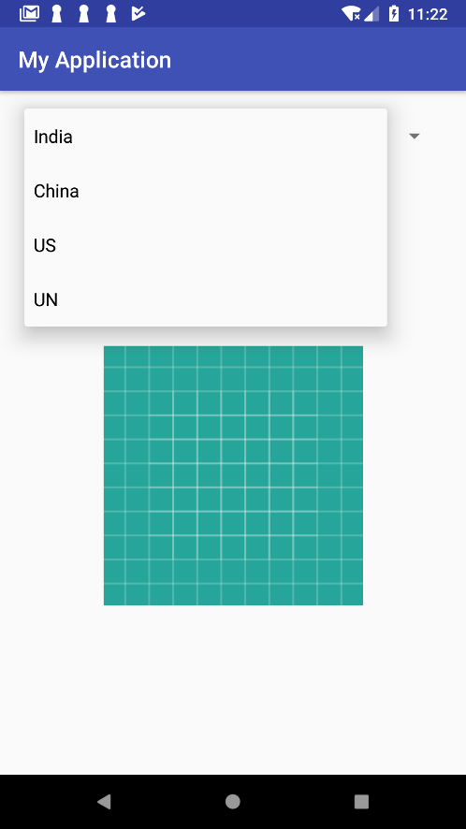

**Understand Menu option. Create an application that will change color of the screen, based on selected options from the menu.**

**CODE:**

**activity_main.xml**

*<?***xml version="1.0" encoding="utf-8"***?>*<**LinearLayout xmlns:android="http://schemas.android.com/apk/res/android"  
 xmlns:app="http://schemas.android.com/apk/res-auto"  
 xmlns:tools="http://schemas.android.com/tools"  
 android:layout_width="match_parent"  
 android:orientation="vertical"  
 android:id="@+id/mainactivity"  
 android:layout_height="match_parent"  
 tools:context="com.example.jainilpatel.menu.MainActivity"**>  
  
 <**TextView android:id="@+id/textView1" android:layout_width="match_parent" android:layout_height="400dp" android:text="Hit Menu Button" android:gravity="center_vertical|center_horizontal" android:textAppearance="?android:attr/textAppearanceLarge"** />  
  
  
 <**TextView  
 android:layout_width="match_parent"  
 android:layout_height="wrap_content"  
 android:text="Created by Jainil Patel(16CE068)"  
 android:textSize="20sp"  
 android:textAlignment="center"**/>  
</**LinearLayout**>

**MainActivity.java**

**package** com.example.jainilpatel.menu;  
  
**import** android.graphics.Color;  
**import** android.os.Bundle;  
**import** android.support.v7.app.AppCompatActivity;  
**import** android.view.Menu;  
**import** android.view.MenuItem;  
**import** android.view.View;  
  
**public class** MainActivity **extends** AppCompatActivity {  
 View **view1**;  
 @Override  
 **protected void** onCreate(Bundle savedInstanceState) {  
 **super**.onCreate(savedInstanceState);  
 setContentView(R.layout.***activity_main***);  
 **view1** = (View) findViewById(R.id.***mainactivity***);  
  
  
 }  
  
 @Override  
 **public boolean** onCreateOptionsMenu(Menu menu) {  
 getMenuInflater().inflate(R.menu.***main***, menu);  
  
 **return true**;  
 }  
  
 @Override  
 **public boolean** onOptionsItemSelected(MenuItem item) {  
 **if**(item.getTitle().equals(**"Red"**)){  
 **view1**.setBackgroundColor(Color.***RED***);  
 }  
 **if**(item.getTitle().equals(**"Blue"**)){  
 **view1**.setBackgroundColor(Color.***BLUE***);  
 }  
 **if**(item.getTitle().equals(**"Yellow"**)){  
 **view1**.setBackgroundColor(Color.***YELLOW***);  
 }  
 **return super**.onOptionsItemSelected(item);  
  
 }  
}

**main.xml**

*<?***xml version="1.0" encoding="utf-8"***?>*<**menu xmlns:android="http://schemas.android.com/apk/res/android"**>  
 <**item android:title="Red"**>Red</**item**>  
 <**item android:title="Blue"**>Blue</**item**>  
 <**item android:title="Yellow"**>Yellow</**item**>  
</**menu**>

**OUTPUT:**

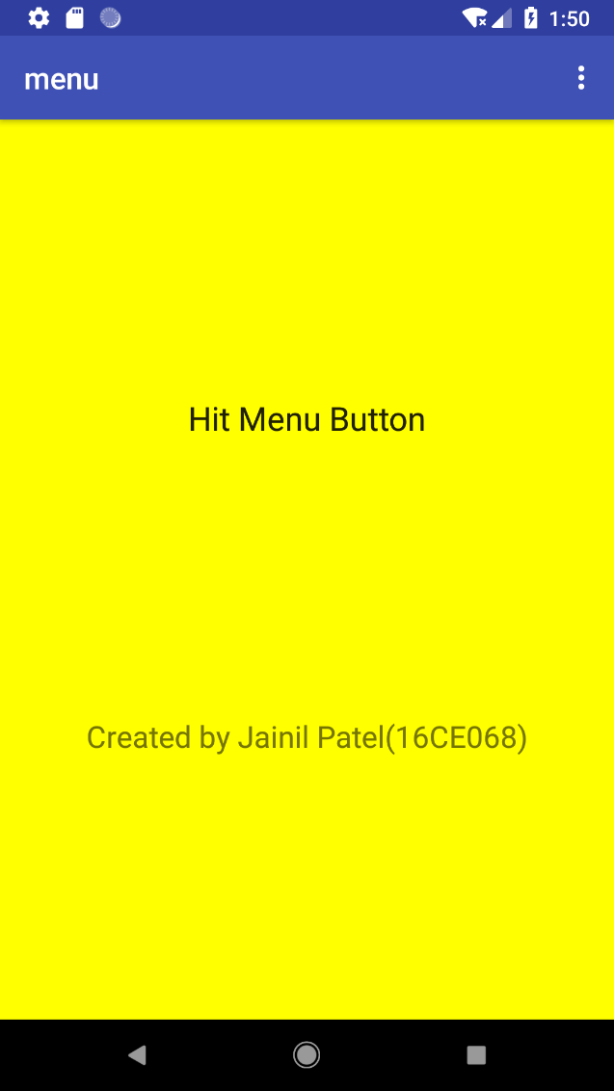

**PRACTICAL 5**

**AIM:** Create an application that will display toast (Message) on specific interval of time. Create an background application that will open activity on specific time. Create an application that will have spinner with list of animation names. On selecting animation name, that animation should affect on the images displayed below.

**CODE:**

Create an application that will display toast (Message) on specific interval of time.

**activity_main.xml**

<?xml version="1.0" encoding="utf-8"?>  
<android.support.constraint.ConstraintLayout xmlns:android="http://schemas.android.com/apk/res/android"  
 xmlns:app="http://schemas.android.com/apk/res-auto"  
 xmlns:tools="http://schemas.android.com/tools"  
 android:layout_width="match_parent"  
 android:layout_height="match_parent"  
 tools:context=".MainActivity">  
  
 <TextView  
 android:id="@+id/textView"  
 android:layout_width="wrap_content"  
 android:layout_height="wrap_content"  
 android:text="text will display after"  
 app:layout_constraintBottom_toBottomOf="parent"  
 app:layout_constraintEnd_toEndOf="parent"  
 app:layout_constraintLeft_toLeftOf="parent"  
 app:layout_constraintRight_toRightOf="parent"  
 app:layout_constraintStart_toStartOf="parent"  
 app:layout_constraintTop_toTopOf="parent" />  
  
 <Chronometer  
 android:id="@+id/timer"  
 android:layout_width="112dp"  
 android:layout_height="wrap_content"  
 android:layout_marginTop="32dp"  
 android:text="Chronometer"  
 android:textAlignment="center"  
 android:visibility="visible"  
 app:layout_constraintEnd_toEndOf="parent"  
 app:layout_constraintStart_toStartOf="parent"  
 app:layout_constraintTop_toBottomOf="@+id/textView" />  
  
 <Button  
 android:id="@+id/button"  
 android:layout_width="wrap_content"  
 android:layout_height="wrap_content"  
 android:layout_marginTop="60dp"  
 android:text="START"  
 app:layout_constraintEnd_toEndOf="parent"  
 app:layout_constraintStart_toStartOf="parent"  
 app:layout_constraintTop_toBottomOf="@+id/editText" />  
  
 <EditText  
 android:id="@+id/editText"  
 android:layout_width="wrap_content"  
 android:layout_height="wrap_content"  
 android:layout_marginEnd="40dp"  
 android:layout_marginTop="64dp"  
 android:ems="10"  
 android:hint="Enter Time"  
 android:inputType="textPersonName"  
 app:layout_constraintEnd_toEndOf="parent"  
 app:layout_constraintTop_toTopOf="parent" />  
  
 <TextView  
 android:id="@+id/textView2"  
 android:layout_width="93dp"  
 android:layout_height="44dp"  
 android:layout_marginEnd="264dp"  
 android:layout_marginTop="64dp"  
 android:text="Time"  
 android:textSize="30sp"  
 app:layout_constraintEnd_toEndOf="parent"  
 app:layout_constraintTop_toTopOf="parent"  
 tools:text="TIME" />  
  
</android.support.constraint.ConstraintLayout>

**activity_main2.xml**

<?xml version="1.0" encoding="utf-8"?>  
<android.support.design.widget.CoordinatorLayout xmlns:android="http://schemas.android.com/apk/res/android"  
 xmlns:app="http://schemas.android.com/apk/res-auto"  
 xmlns:tools="http://schemas.android.com/tools"  
 android:layout_width="match_parent"  
 android:layout_height="match_parent"  
 tools:context=".Main2Activity">  
  
 <android.support.design.widget.AppBarLayout  
 android:layout_width="match_parent"  
 android:layout_height="wrap_content"  
 android:theme="@style/AppTheme.AppBarOverlay">  
  
 <android.support.v7.widget.Toolbar  
 android:id="@+id/toolbar"  
 android:layout_width="match_parent"  
 android:layout_height="?attr/actionBarSize"  
 android:background="?attr/colorPrimary"  
 app:popupTheme="@style/AppTheme.PopupOverlay" />  
  
 </android.support.design.widget.AppBarLayout>  
  
 <include layout="@layout/content_main2" />  
  
 <android.support.design.widget.FloatingActionButton  
 android:id="@+id/fab"  
 android:layout_width="wrap_content"  
 android:layout_height="wrap_content"  
 android:layout_gravity="bottom|end"  
 android:layout_margin="@dimen/fab_margin"  
 app:srcCompat="@android:drawable/ic_dialog_email" />  
  
</android.support.design.widget.CoordinatorLayout>

**MainActivity.java**

package com.example.jainilpatel.myapplication;  
  
import android.content.Intent;  
import android.support.v7.app.AppCompatActivity;  
import android.os.Bundle;  
import android.view.View;  
import android.widget.Button;  
import android.widget.Chronometer;  
import android.widget.EditText;  
import android.widget.TextView;  
import android.widget.Toast;  
  
public class MainActivity extends AppCompatActivity {  
EditText e;  
Button b;  
TextView t;  
Chronometer c;  
int i=1;  
int count=5;  
 @Override  
 protected void onCreate(Bundle savedInstanceState) {  
 super.onCreate(savedInstanceState);  
 setContentView(R.layout.activity_main);  
 e=findViewById(R.id.editText);  
 b=findViewById(R.id.button);  
 t=findViewById(R.id.textView);  
 c=findViewById(R.id.timer);  
 b.setOnClickListener(new View.OnClickListener() {  
 @Override  
 public void onClick(View v) {  
 final int time=Integer.parseInt(e.getText().toString());  
 //Toast.makeText(MainActivity.this, String.valueOf(time), Toast.LENGTH_SHORT).show();  
  
 c.start();  
 c.setOnChronometerTickListener(new Chronometer.OnChronometerTickListener() {  
 @Override  
 public void onChronometerTick(Chronometer chronometer) {  
 t.setText("Your text will be displayed after "+(time-i)+" Seconds");  
 i++;  
 if(time-i==-1&&count>0)  
 {  
 Toast.makeText(MainActivity.this, "MESSAGE DISPLAYED", Toast.LENGTH_SHORT).show();  
 i=0;  
 Intent intent=new Intent(MainActivity.this,Main2Activity.class);  
 intent.putExtra("time",String.valueOf(time));  
 startActivity(intent);  
 count--;  
 }  
 if(count==0)  
 {  
 c.stop();  
 }  
  
  
 }  
 });  
 }  
 });  
 }  
}

**Main2Activity.java**

package com.example.jainilpatel.myapplication;  
  
import android.content.Intent;  
import android.os.Bundle;  
import android.os.Handler;  
import android.support.design.widget.FloatingActionButton;  
import android.support.design.widget.Snackbar;  
import android.support.v7.app.AppCompatActivity;  
import android.support.v7.widget.Toolbar;  
import android.view.View;  
  
public class Main2Activity extends AppCompatActivity {  
  
 @Override  
 protected void onCreate(Bundle savedInstanceState) {  
 super.onCreate(savedInstanceState);  
 setContentView(R.layout.activity_main2);  
 Toolbar toolbar = (Toolbar) findViewById(R.id.toolbar);  
 setSupportActionBar(toolbar);  
 Intent i=getIntent();  
 Integer t=Integer.parseInt(i.getStringExtra("time"));  
  
  
 FloatingActionButton fab = (FloatingActionButton) findViewById(R.id.fab);  
 fab.setOnClickListener(new View.OnClickListener() {  
 @Override  
 public void onClick(View view) {  
 Snackbar.make(view, "Replace with your own action", Snackbar.LENGTH_LONG)  
 .setAction("Action", null).show();  
 }  
 });  
 final Handler handler = new Handler();  
 handler.postDelayed(new Runnable() {  
 @Override  
 public void run() {  
 //Do something after ms  
 Main2Activity.super.onBackPressed();  
 }  
 }, t*1000);  
  
 //startActivity(new Intent(Main2Activity.this,MainActivity.class));  
 }  
}

**OUTPUT:**

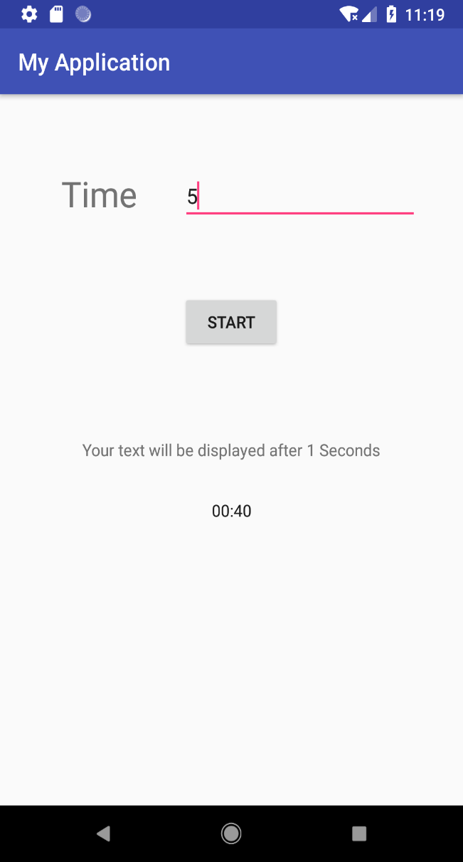 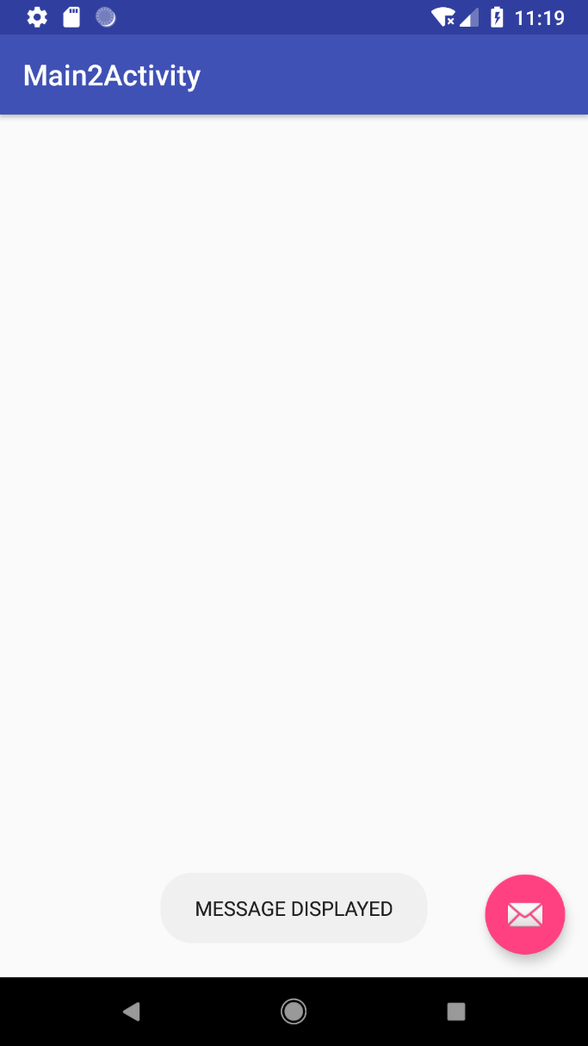

**CODE:**

Create a background application that will open activity on specific time.

**activity_main.xml**

<?xml version="1.0" encoding="utf-8"?>  
<android.support.constraint.ConstraintLayout xmlns:android="http://schemas.android.com/apk/res/android"  
 xmlns:app="http://schemas.android.com/apk/res-auto"  
 xmlns:tools="http://schemas.android.com/tools"  
 android:layout_width="match_parent"  
 android:layout_height="match_parent"  
 tools:context=".MainActivity">  
  
 <Button  
 android:id="@+id/button"  
 android:layout_width="wrap_content"  
 android:layout_height="wrap_content"  
 android:layout_marginTop="132dp"  
 android:text="Start"  
 app:layout_constraintEnd_toEndOf="parent"  
 app:layout_constraintStart_toStartOf="parent"  
 app:layout_constraintTop_toTopOf="parent" />  
  
 <Button  
 android:id="@+id/button2"  
 android:layout_width="wrap_content"  
 android:layout_height="wrap_content"  
 android:layout_marginTop="48dp"  
 android:text="Stop"  
 app:layout_constraintEnd_toEndOf="parent"  
 app:layout_constraintStart_toStartOf="parent"  
 app:layout_constraintTop_toBottomOf="@+id/button" />  
</android.support.constraint.ConstraintLayout>

**musicplayer.java**

package com.example.jainilpatel.myapplication;  
  
import android.app.Service;  
import android.content.Intent;  
import android.media.MediaPlayer;  
import android.os.IBinder;  
import android.provider.Settings;  
import android.support.annotation.Nullable;  
  
public class musicplayer extends Service{  
 MediaPlayer player;  
  
  
 @Override  
 public IBinder onBind(Intent intent) {  
 return null;  
 }  
  
 public int onStartCommand(Intent intent, int flags, int startId) {  
 player=MediaPlayer.create(this, Settings.System.DEFAULT_RINGTONE_URI);  
 player.setLooping(true);  
 player.start();  
 return START_STICKY;  
 //return super.onStartCommand(intent, flags, startId);  
 }  
 @Override  
 public void onDestroy() {  
 super.onDestroy();  
 player.stop();  
 }  
}

**MainActivity.java**

package com.example.jainilpatel.myapplication;  
  
import android.content.Intent;  
import android.support.v7.app.AppCompatActivity;  
import android.os.Bundle;  
import android.view.View;  
import android.widget.Button;  
  
public class MainActivity extends AppCompatActivity{  
  
 Button start,stop;  
 @Override  
 protected void onCreate(Bundle savedInstanceState) {  
 super.onCreate(savedInstanceState);  
 setContentView(R.layout.activity_main);  
 start=(Button)findViewById(R.id.button);  
 stop=(Button)findViewById(R.id.button2);  
 start.setOnClickListener(new View.OnClickListener() {  
 @Override  
 public void onClick(View v) {  
 startService(new Intent(MainActivity.this,musicplayer.class));  
 }  
 });  
 stop.setOnClickListener(new View.OnClickListener() {  
 @Override  
 public void onClick(View v) {  
 stopService(new Intent(MainActivity.this,musicplayer.class));  
 }  
 });  
 }  
}

**OUTPUT:**

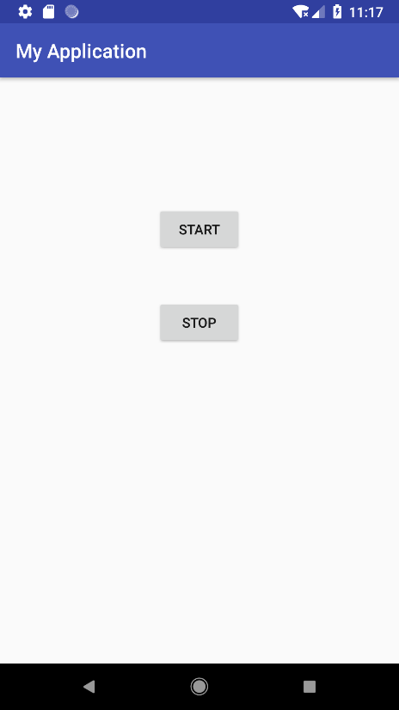

**CODE:**

Create an application that will have spinner with list of animation names. On selecting animation name, that animation should affect on the images displayed below.

**activity_main.xml**

<?xml version="1.0" encoding="utf-8"?>  
<android.support.constraint.ConstraintLayout xmlns:android="http://schemas.android.com/apk/res/android"  
 xmlns:app="http://schemas.android.com/apk/res-auto"  
 xmlns:tools="http://schemas.android.com/tools"  
 android:layout_width="match_parent"  
 android:layout_height="match_parent"  
 tools:context=".MainActivity"  
 android:id="@+id/relativeLayout">  
  
 <ImageView  
 android:id="@+id/imageView"  
 android:layout_width="318dp"  
 android:layout_height="328dp"  
 android:layout_marginBottom="32dp"  
 android:src="@drawable/i1"  
 app:layout_constraintBottom_toBottomOf="parent"  
 app:layout_constraintLeft_toLeftOf="parent"  
 app:layout_constraintRight_toRightOf="parent" />  
  
 <Spinner  
 android:id="@+id/spinner"  
 android:layout_width="292dp"  
 android:layout_height="wrap_content"  
 android:layout_marginTop="48dp"  
 app:layout_constraintLeft_toLeftOf="parent"  
 app:layout_constraintRight_toRightOf="parent"  
 app:layout_constraintTop_toTopOf="parent" />  
  
</android.support.constraint.ConstraintLayout>

*res\anim\alpha.xml*

<?xml version="1.0" encoding="utf-8"?>  
<set xmlns:android="http://schemas.android.com/apk/res/android">  
 <alpha  
 android:fromAlpha="0"  
 android:toAlpha="1.0"  
 android:fillAfter="true"  
 android:duration="7000"  
 />  
</set>

*res\anim\rotate.xml*

<?xml version="1.0" encoding="utf-8"?>  
<set xmlns:android="http://schemas.android.com/apk/res/android">  
 <rotate  
 android:fromDegrees="0"  
 android:toDegrees="-360"  
 android:pivotX="50%"  
 android:pivotY="50%"  
 android:duration="7000"  
 />  
</set>

*res\anim\scale.xml*

<?xml version="1.0" encoding="utf-8"?>  
<set xmlns:android="http://schemas.android.com/apk/res/android">  
 <scale  
 android:pivotY="50%"  
 android:pivotX="50%"  
 android:fromXScale="1.0"  
 android:fromYScale="1.0"  
 android:toXScale="2.0"  
 android:toYScale="2.0"  
 android:duration="7000"  
 />  
</set>

*res\nim\spin.xml*

<?xml version="1.0" encoding="utf-8"?>  
<set xmlns:android="http://schemas.android.com/apk/res/android">  
 <rotate  
 android:pivotY="50%"  
 android:pivotX="50%"  
 android:fromDegrees="0"  
 android:toDegrees="360"  
 android:duration="7000"  
 android:repeatCount="infinite"  
 />  
</set>

*res\nim\translate.xml*

<?xml version="1.0" encoding="utf-8"?>  
<set xmlns:android="http://schemas.android.com/apk/res/android">  
 <translate  
 android:fromXDelta="110"  
 android:fromYDelta="190"  
 android:toXDelta="-120"  
 android:toYDelta="0"  
 android:duration="4000"  
 android:fillAfter="true"  
 />  
</set>

**MainActivity.java**

package com.example. jainilpatel.practical5animations;  
  
import android.support.v7.app.AppCompatActivity;  
import android.os.Bundle;  
import android.view.View;  
import android.view.animation.Animation;  
import android.view.animation.AnimationUtils;  
import android.widget.AdapterView;  
import android.widget.ArrayAdapter;  
import android.widget.ImageView;  
import android.widget.Spinner;  
  
public class MainActivity extends AppCompatActivity implements AdapterView.OnItemSelectedListener{  
 Spinner spnr;  
 ImageView imgmaster;  
 ArrayAdapter<CharSequence> adapter;  
 @Override  
 protected void onCreate(Bundle savedInstanceState) {  
 super.onCreate(savedInstanceState);  
 setContentView(R.layout.activity_main);  
  
 spnr=(Spinner) findViewById(R.id.spinner);  
 imgmaster=(ImageView) findViewById(R.id.imageView);  
  
 adapter = ArrayAdapter.createFromResource(this,R.array.Animation,android.R.layout.simple_spinner_item);  
 spnr.setAdapter(adapter);  
 spnr.setOnItemSelectedListener(this);  
 }  
  
 @Override  
 public void onItemSelected(AdapterView<?> adapterView, View view, int position, long l) {  
 Animation anim = AnimationUtils.loadAnimation(this,R.anim.alpha);  
 if(spnr.getSelectedItem().equals("Alpha")){  
 anim = AnimationUtils.loadAnimation(this,R.anim.alpha);  
 }  
 else if(spnr.getSelectedItem().equals("Rotate")){  
 anim = AnimationUtils.loadAnimation(this,R.anim.rotate);  
 }  
 else if(spnr.getSelectedItem().equals("Scale")){  
 anim = AnimationUtils.loadAnimation(this,R.anim.scale);  
 }  
 else if(spnr.getSelectedItem().equals("Spin")){  
 anim = AnimationUtils.loadAnimation(this,R.anim.spin);  
 }  
 else if(spnr.getSelectedItem().equals("Translate")){  
 anim = AnimationUtils.loadAnimation(this,R.anim.translate);  
 }  
 imgmaster.startAnimation(anim);  
 }  
  
 @Override  
 public void onNothingSelected(AdapterView<?> adapterView) {  
  
 }  
}

**OUTPUT:**

